- January's strong rise in UK mortgage approvals pointed to looser financial conditions feeding through to the housing market. So did another gain in Nationwide's measure of house prices. Meanwhile, we think dissaving should aid a consumer recovery this year. But the latest data offered a mixed picture about potential support from this source.
- Comments by Monetary Policy Committee members this week delivered no real surprises. Arch-hawk Catherine Mann showed little sign that she's moving away from her previous support for tighter monetary policy, while Dave Ramsden reiterated the MPC's cautious language around the prospect of interest rate cuts.
In assessing the impact on the economy from the general decline in market interest rates since the peaks of last summer, an interest-rate sensitive sector like housing is the canary in the coalmine. A strong rise in mortgage approvals in January, the fourth monthly increase in a row, suggests a positive effect is increasingly coming through. 55,227 mortgages were approved that month, up from 51,506 in December. This left approvals at the highest level since October 2022, just before "mini-budget" related turmoil caused mortgage demand to slump.
Somewhat surprisingly, given the lags between approvals and mortgage lending and the pick-up in the former in recent months, net mortgage lending remained in negative territory for the second successive month in January. In fact, the £1.1bn of mortgage debt repaid was a little bigger than December's £0.9bn repayment (Chart 1). This meant year-on-year growth in net mortgage lending in January turned negative for the first time since the data series began in 1994.
Still, the recovery in approvals since last autumn means it shouldn't be long before net lending turns positive again. And though monthly data for house prices should be treated with a large pinch of salt in a low transaction market, that Nationwide's measure of house prices rose on a year-on-year basis for the first time since January 2023 also suggests housing demand has firmed of late.
Chart 1: Mortgage approvals continued to rise in early 2024, but net lending fell
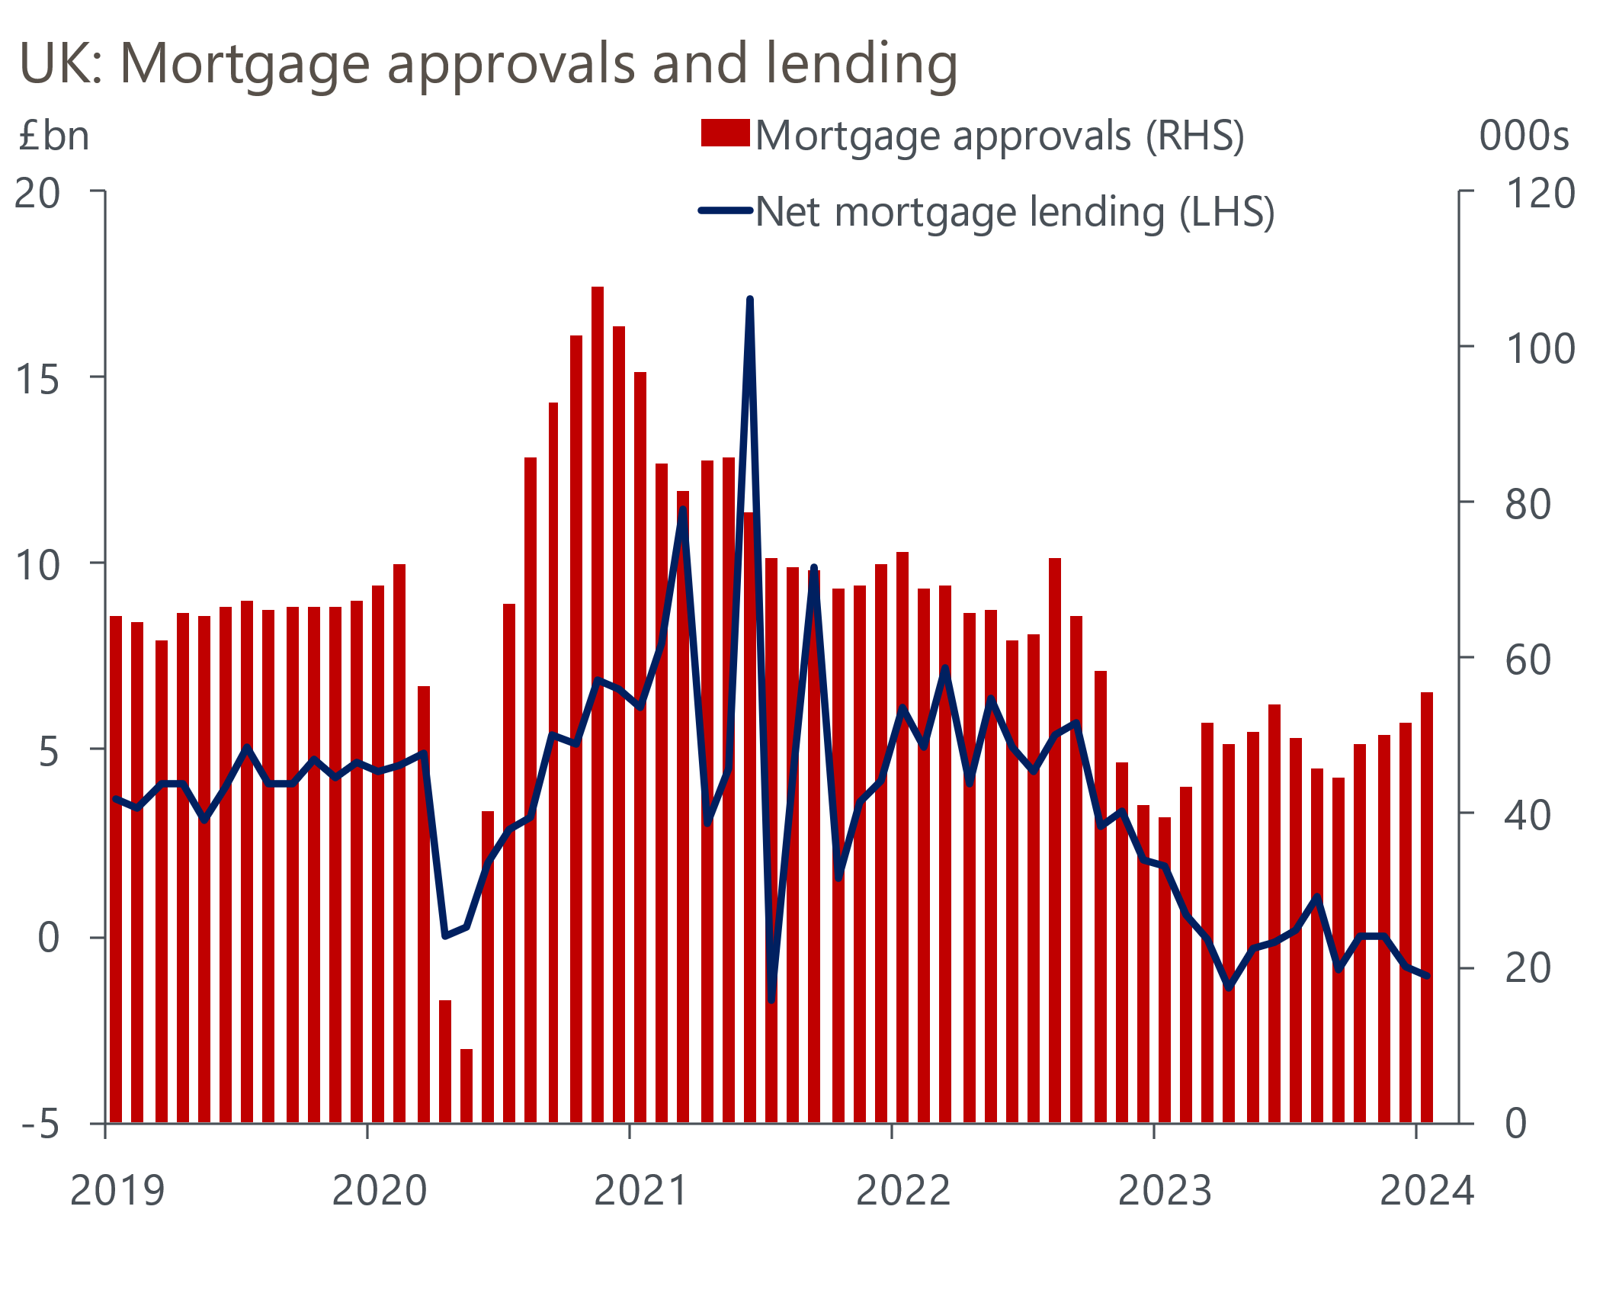
Source : Oxford Economics/Haver Analytics

Still, signs of life in the housing market shouldn't be overdone. Approvals in January were still a tenth below the 2022 average, reflecting the fact that while mortgage affordability has improved recently, it remains stretched relative to past norms. True, the average interest rate on new mortgages dipped in January. But it was still over 350bps higher than 2021's low. And there's already evidence that quoted mortgage rates are rising in response to markets paring back expectations of the scale of Bank of England rate cuts this year.
Comments from some Monetary Policy Committee members this week offered no reason for investors to row back on their more cautious view. Catherine Mann, one of the two MPC members who voted to raise rates in February, argued that stickiness in services inflation was partly a consequence of “a lack of consumer discipline” in reining in businesses’ pricing power. Mann cited better-off households continuing to spend “disproportionately” on travel, eating out, and entertainment, despite higher mortgage costs. Her argument implies she's not yet ready to fall in with the consensus on the MPC, let alone support a rate cut.
Dave Ramsden, who voted with the majority to keep rates on hold last month, stuck to the party line by reiterating language used in February's policy statement. In a Q&A session following a speech on the BoE's role in bond markets, Ramsden said that inflation in services prices remained too high and that he wanted more evidence that it was easing before considering a cut in rates. On a separate MPC-related note, the Chancellor announced that Clare Lombardelli, currently Chief Economist of the OECD, will succeed Ben Broadbent as the BoE's Deputy Governor for Monetary Policy. Her term begins in July.
As for economic developments that may influence the MPC's thinking, this week was a relatively light one. A rise in net unsecured lending to £1.9bn in January from December's £1.3bn was ostensibly a positive for consumer spending. But the increase was a function of lower repayments, with gross lending down slightly. However, as we explored in a recent research note, an improved financial outlook, stronger consumer sentiment, and households' relatively low debt levels should support boost consumers' appetite to borrow.
The impact of the shift in interest rate expectations is also being reflected in savings behaviour. The average interest rate on new time deposits has fallen 74bps in the past three months. Probably as a consequence of this, January saw virtually no net change in savings held in fixed-term savings accounts. But households moved £7.2bn into interest-bearing instant-access accounts. This was the biggest inflow since June 2021 (Chart 2).
Chart 2: Households moved savings into a more liquid form in January
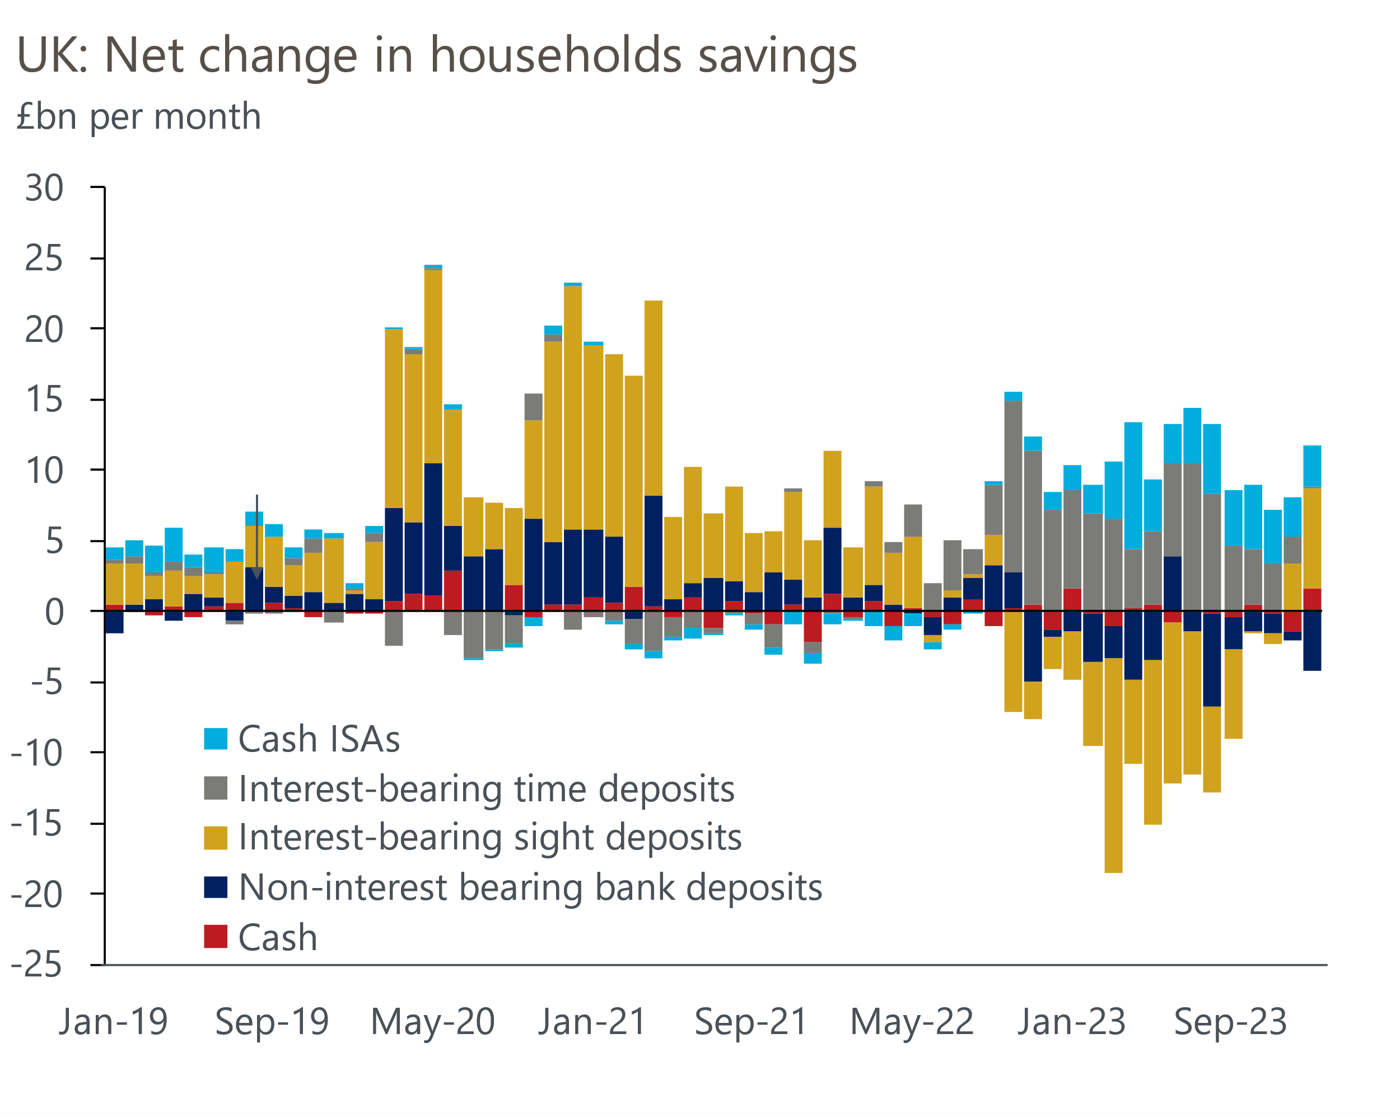
Source: Oxford Economics calculations using data from Bank of England
Moving from the savers to the makers, February's S&P Global/CIPS manufacturing survey confirmed the message of the earlier flash reading, pointing to a sector still stuck in the doldrums but showing some signs of improvement. The survey's manufacturing output balance rose to a three-month high. But disruption to shipping in the Red Sea continued to put upward pressure on costs, part of which was passed on in the form of higher selling prices.

The week ahead
The Budget on Wednesday could prove to be the last fiscal event before the next general election, so Chancellor Jeremy Hunt will be under pressure to deliver tax cuts.
Key to Hunt's ability to do this will be how much headroom the OBR judges the Chancellor has against his main fiscal goal of debt falling as a share of GDP in five years’ time. All else equal, lower gilt yields and market expectations for Bank Rate and stronger population projections should boost that headroom. Hunt could also create some extra fiscal space by assuming an even more implausible post-election spending squeeze, or raising some taxes – on that front, speculation has centred on ending or restricting non-domicile tax benefits. On the other hand, there's a chance that the OBR may rein back its current punchy assumption for productivity growth, which would cut headroom.
On balance, we think the OBR's forecasts will be slightly more favourable to the Chancellor and that he will use this to announce some high-profile 'giveaways', with a cut in income tax or National Insurance the most likely options.
February's services PMI should reinforce the positive message from the earlier flash reading. The flash services PMI of 54.3 was unchanged from January's eight-month high, with survey respondents citing support from a turnaround in business and consumer spending and less restrictive financial conditions. We expect little change in the final services PMI, with the index expected to come in at 54.5.
Table 1: Week ahead calendar
Date | Events | Period | Measure | Unit | Previous | Forecast
Mar 5 | S&P Global/CIPS services | Feb | PMI | % bal | 54.3 | 54.5
Mar 5 | S&P Global/CIPS composite | Feb | PMI | % bal | 53.3 | 53.4
Mar 6 | S&P Global/CIPS construction | Feb | PMI | % bal | 48.8 | 49.3
Mar 6 | Budget
Mar 7 | Halifax house prices | Feb | m/m | % | 1.3 | 0.2
Mar 7 | Halifax house prices | Feb | y/y | % | 2.5 | 2.1
Source: Oxford Economics

Key forecasts
Table 2: UK forecast overview
(Annual percentage changes unless specified)
 | 2022 | 2023 | 2024 | 2025 | 2026 | 2027
GDP | 4.3 | 0.1 | 0.4 | 1.8 | 2.0 | 1.7
Private consumption | 4.8 | 0.3 | 0.6 | 2.2 | 2.2 | 1.8
Fixed investment | 8.0 | 2.9 | -2.8 | 0.4 | 2.6 | 2.2
Government consumption | 2.3 | 0.6 | 3.9 | 2.5 | 1.6 | 1.5
Exports of goods and services | 9.0 | -1.4 | -1.0 | 2.8 | 2.4 | 1.7
Imports of goods and services | 14.6 | -1.6 | 1.1 | 3.3 | 3.0 | 2.0
Industrial Production | -3.5 | -0.3 | 0.2 | 0.9 | 1.5 | 1.1
Consumer prices | 9.1 | 7.3 | 2.1 | 2.1 | 2.2 | 2.1
Unemployment rate (%) | 3.9 | 4.0 | 4.0 | 3.9 | 3.8 | 3.8
Current a/c balance (% of GDP) | -3.1 | -2.8 | -2.9 | -2.9 | -3.0 | -2.9
Government balance (% of GDP) | 4.4 | 5.2 | 3.3 | 2.6 | 2.0 | 1.4
Cen. bank policy rate (%, EOP) | 3.50 | 5.25 | 4.50 | 3.50 | 2.50 | 2.00
10yr govt. bond yield (%, EOP) | 3.67 | 3.54 | 3.76 | 3.46 | 3.02 | 2.85
Exchange rate (US$ per £, EOP) | 1.20 | 1.27 | 1.27 | 1.29 | 1.32 | 1.35
Exchange rate (euro per £, EOP) | 1.13 | 1.15 | 1.17 | 1.16 | 1.15 | 1.15
Source: Oxford Economics
Table 3: Quarterly forecasts for the UK
 | 2023 |  |  |  | 2024
 | Q1 | Q2 | Q3 | Q4 | Q1 | Q2 | Q3 | Q4
GDP (% year) | 0.3 | 0.3 | 0.2 | -0.2 | -0.2 | 0.1 | 0.5 | 1.2
CPI inflation (% year) | 10.2 | 8.4 | 6.7 | 4.2 | 3.4 | 1.6 | 1.8 | 1.8
Bank Rate (%, EOP) | 4.25 | 5.00 | 5.25 | 5.25 | 5.25 | 5.00 | 4.75 | 4.50
10yr gilt yield (%, EOP) | 3.47 | 4.39 | 4.46 | 3.54 | 4.00 | 3.86 | 3.81 | 3.76
US$ per £ (EOP) | 1.24 | 1.27 | 1.22 | 1.27 | 1.26 | 1.26 | 1.26 | 1.27
Euro per £ (EOP) | 1.14 | 1.17 | 1.15 | 1.15 | 1.17 | 1.17 | 1.17 | 1.17
Source: Oxford Economics

Latest Country Economic Forecast:
February 20, 2024

Recent publications

Data Insights
Manufacturing sector remained in a weak spot in February
Mortgage approvals rise, but net lending remains negative
PMIs signal stronger activity and price pressures
Extra fiscal headroom is looking more limited
Retail sales rebounded in January

Research Briefings
Dissaving should give some aid to a consumer recovery
Lower inflation to support a gradual recovery in real incomes
Slowing labour supply puts the onus on productivity gains
Tight labour market and firm pay growth will worry the MPC
BoE suggests rate cuts are coming…but not quite yet

Contacts

Oxford Economics' UK team
- Andrew Goodwin - Chief UK Economist - agoodwin@oxfordeconomics.com
- Edward Allenby - UK Economist - eallenby@oxfordeconomics.com

